

台州学院
《Java高级程序设计》
实验报告

实验项目: 实验3 Servlet和JSP应用
学号姓名: 2X计奇2X00000000无名氏
专 业：计算机科学与技术
班 级：21计应1班
实验时间：第4-9次课 三/四/五

电子与信息工程学院

一、实验目的及要求：
1）结合使用Servlet和JSP，实现对数据库增删改查;
2）熟练使用JSP九大隐含对象;
3）转发应用;
4）mvc初步。

二、实验内容：
1.使用MVC框架思想，采用entity、dao、util、servlet包和jsp，对表t_emp（id，name，salary，age）进行数据操作管理，即增、删、改、查。 (1)在web层，写一个控制器servlet，取名Mgmt.java，实现web层的流程调度；（2）在业务层的dao层实现对数据库中表t_emp的增、删、改、查操作：（3）在视图层，即数据展现层，写三个jsp，一个emplist.jsp显示查询结果，一个addEmp.jsp展现增加数据页面，一个loadEmp.jsp展现需要修改数据页面。要求使用转发。

三、实验代码及运行结果（包括可能有的截图）：

Dao.EmployeeDAO

package dao;

import entity.Employee;

import util.DBUtil_d;

import java.sql.*;

import java.util.ArrayList;

import java.util.List;

public class EmployeeDAO {

public List<Employee> list()throws Exception{

List<Employee> employees=new ArrayList<>();

Connection conn= DBUtil_d.getConnection();

Statement stat=conn.createStatement();

ResultSet rst=stat.executeQuery("select * from t_emp");

while(rst.next()){

Employee e=new Employee();

e.setID(rst.getLong("id"));

e.setName(rst.getString("name"));

e.setSalary(rst.getDouble("salary"));

e.setAge(rst.getInt("age"));

employees.add(e);

}

DBUtil_d.close(conn);

return employees;

}

public void del(long id)throws Exception{

try{

Connection conn= DBUtil_d.getConnection();

PreparedStatement prep=conn.prepareStatement("delete from t_emp where id = ?");

prep.setLong(1,id);

prep.executeUpdate();

DBUtil_d.close(conn);

}catch (SQLException e) {

e.printStackTrace();

}

}

public void add(String name,double salary,int age)throws Exception{

try{

Connection conn= DBUtil_d.getConnection();

PreparedStatement prep = conn.prepareStatement("insert into t_emp(name,salary,age) values(?,?,?)");

prep.setString(1,name);

prep.setDouble(2,salary);

prep.setInt(3,age);

prep.executeUpdate();

DBUtil_d.close(conn);

}catch (SQLException e){

e.printStackTrace();

}

}

public Employee find(long ID)throws Exception{

Connection conn= DBUtil_d.getConnection();

Statement stat=conn.createStatement();

PreparedStatement prep= conn.prepareStatement("select *from t_emp where id=?");

prep.setLong(1,ID);

ResultSet rst= prep.executeQuery();

Employee e=new Employee();

while(rst.next()){

e.setID(rst.getLong("id"));

e.setName(rst.getString("name"));

e.setSalary(rst.getDouble("salary"));

e.setAge(rst.getInt("age"));

}

DBUtil_d.close(conn);

return e;

}

public void update(long id,String name,double salary,int age)throws Exception{

try{

Connection conn=DBUtil_d.getConnection();

PreparedStatement prep=conn.prepareStatement("update t_emp set name=?,salary=?,age=? where id=?");

prep.setString(1,name);

prep.setDouble(2,salary);

prep.setInt(3,age);

prep.setLong(4,id);

prep.executeUpdate();

DBUtil_d.close(conn);

} catch (Exception e) {

e.printStackTrace();

}

}

}

Entity.Employee

package entity;

public class Employee {

private long id;

private String name;

private double salary;

private int age;

public Employee(long id,String name, double salary,int age){

}

public Employee(){

}

public int getAge(){ return age; }

public void setAge(int age){ this.age= age; }

public long getId(){ return id; }

public void setID(long id){ this.id= id; }

public String getName(){ return name; }

public void setName(String name){ this.name= name; }

public double getSalary(){return salary;}

public void setSalary(double salary){this.salary=salary;}

}
Servlet.MgmtEmp2

package Servlet;

import dao.EmployeeDAO;
import entity.Employee;

import javax.servlet.*;
import javax.servlet.http.*;
import javax.servlet.annotation.*;
import java.io.IOException;
import java.util.List;

@WebServlet("/action")
public class MgmtEmp2 extends HttpServlet {
protected void service(HttpServletRequest request, HttpServletResponse response) throws ServletException, IOException {
String path=request.getParameter("path");
if(path.equals("/list")) {
EmployeeDAO dao = new EmployeeDAO();
try {
List<Employee> employees = dao.list();
request.setAttribute("employees", employees);
request.getRequestDispatcher("emplist.jsp").forward(request, response);
} catch (Exception e) {
e.printStackTrace();
throw new ServletException(e);
}
}else if(path.equals("/delEmp")){
EmployeeDAO dao = new EmployeeDAO();
long id=Long.parseLong(request.getParameter("id"));
try {
dao.del(id);
request.getRequestDispatcher("/action?path=/list").forward(request, response);
} catch (Exception e) {
e.printStackTrace();
throw new ServletException(e);
}
}else if(path.equals("/add")){
String name=request.getParameter("name");
double salary= Double.parseDouble(request.getParameter("salary"));
int age= Integer.parseInt(request.getParameter("age"));
EmployeeDAO dao = new EmployeeDAO();
try{
dao.add(name,salary,age);
request.getRequestDispatcher("/action?path=/list").forward(request, response);
} catch (Exception e) {
e.printStackTrace();
throw new ServletException(e);
}
}else if(path.equals("/loadEmp")){
EmployeeDAO dao=new EmployeeDAO();
long id=Long.parseLong(request.getParameter("id"));
try {
Employee e=dao.find(id);
request.setAttribute( "Employee",e);
request.getRequestDispatcher("/updateEmp.jsp").forward(request, response);
} catch (Exception ex) {
ex.printStackTrace();
}
}else if(path.equals("/updateEmp")){
EmployeeDAO dao=new EmployeeDAO();
long id=Long.parseLong(request.getParameter("id"));
String name=request.getParameter("name");
double salary= Double.parseDouble(request.getParameter("salary"));
int age= Integer.parseInt(request.getParameter("age"));
try{
dao.update(id,name,salary,age);
request.getRequestDispatcher("/action?path=/list").forward(request, response);
} catch (Exception e) {
e.printStackTrace();
throw new ServletException(e);
}
}
}
}
Util.DBUtil_d
package util;

import java.sql.Connection;
import java.sql.DriverManager;
import java.sql.SQLException;

public class DBUtil_d {
public static Connection getConnection(){
Connection conn=null;
try{
Class.forName("com.mysql.jdbc.Driver");
conn= DriverManager.getConnection("jdbc:mysql://localhost:3306/db5113",
"root","123456");
} catch (ClassNotFoundException e) {
e.printStackTrace();
}catch (SQLException e){
e.printStackTrace();
}
return conn;
}
public static void close(Connection conn){
if(conn!=null) {
try{
conn.close();
} catch (SQLException e) {
e.printStackTrace();
}
}
}
}
addEmp.jsp
<html>
<head></head>
<body style=...">
<form action="action?path=/add" method="post">
<fieldset>
<legend>add</legend>
name:<input type="text" name="name"/><br/>
salary:<input type="text" name="salary"/><br/>
age:<input type="text" name="age"/><br/>
<input type="submit" value="Confirm" onclick="location='action?path=/list'"/>
</fieldset>
</form>
</body>
</html>
Emplist.jsp
<%@page import="java.util.*,entity.*" %>
<html>
<head>
<title>emplist</title>
<meta http-equiv="Content-Type" content="text/html; charset=UTF-8">
<link rel="stylesheet" type="text/css" href="css/style.css" />
</head>
<body>
<div id="wrap">
<div id="top_content">
<div id="header">
<div id="rightheader">
<p>
2009/11/20
<br />
</p>
</div>
<div id="topheader">
<h1 id="title">
<a href="#">main</a>
</h1>
</div>
<div id="navigation">
</div>
</div>
<div id="content">
<p id="whereami">
</p>
<h1>
Welcome!
</h1>
<table class="table">
<tr class="table_header">
<td>
ID
</td>
<td>
Salary
</td>
<td>
Age
</td>
<td>
Operation
</td>
</tr>
<%
List<Employee> employees=(List<Employee>)request.getAttribute("employees");
for(int i=0;i<employees.size();i++){
Employee e =employees.get(i);
%>
<tr class="row<%=(i%2 +1)%>">
<td>
<%=e.getId()%>
</td>
<td>
<%=e.getName()%>
</td>
<td>
<%=e.getSalary()%>
</td>
<td>
<%=e.getAge()%>
</td>
<td>
<a href="action?path=/delEmp&id=<%=e.getId()%>">delete emp</a>
<a href="action?path=/loadEmp&id=<%=e.getId()%>">update emp</a>
</td>
<tr>
<%
}
%>
</table>
<p>
<input type="button" class="button" value="Add Employee" onclick="location='addEmp.jsp'"/>
</p>
</div>
</div>
<div id="footer">
<div id="footer_bg">
ABC@126.com
</div>
</div>
</div>
</body>
</html>
UpdateEmp.jsp
<%@ page import="entity.Employee" %>
<html>
<head></head>
<body style=...">
<form action="action?path=/updateEmp" method="post">
<fieldset>
<legend>update</legend>
<%
Employee e=(Employee) request.getAttribute( "Employee");
%>
id:<input type="text" name="id" value="<%=e.getId()%>"/><br/>
name:<input type="text" name="name" value="<%=e.getName()%>"/><br/>
salary:<input type="text" name="salary" value="<%=e.getSalary()%>"/><br/>
age:<input type="text" name="age" value="<%=e.getAge()%>"/><br/>
<input type="submit" value="Confirm" onclick="location='action?path=/list'"/>
</fieldset>
</form>
</body>
</html>
Css.style

body
{
margin: 0;
font-size: 62.5%;
font-family: Verdana, Arial, Helvetica, sans-serif;
padding: 15px 0;
background: #eeeeee;
}

#wrap {
width: 820px;
margin: 0 auto;
background: url(../img/bg.gif) top center repeat-y #FFFFFF;
}

#top_content {
padding: 0 10px;
}

#topheader {
padding: 25px 15px 15px 15px;
margin: 0 auto 0 auto;
background: url(../img/top_left.gif) top left repeat-x #85C329;
}

#rightheader {
float: right;
width: 375px;
height: 40px;
color: #FFFFFF;
text-align: right;
}
#rightheader p {
padding: 35px 15px 0 0;
margin: 0;
text-align: right;
}
#rightheader p span {
font-weight: bold;
}
#rightheader a:link, #rightheader a:visited {
color: #FFFFFF;
text-decoration: underline;
}

#title {
padding: 0;
margin: 0;
font-size: 2.5em;
color: #FFFFFF;
}
#title span {
font-size: 0.5em;
font-style: italic;
}
#title a:link, #title a:visited {
color: #FFFFFF;
text-decoration: none;
}
#title a:hover {
color: #E1F3C7;
}

#navigation {
background: #74A8F5;
border-top: 1px solid #ffffff;
height: 25px;
clear: both
}
#navigation ul {
padding: 0;
margin: 0;
list-style: none;
font-size: 1.1em;
height: 25px;
}
#navigation ul li {
display: inline;
}
#navigation ul li a {
color: #FFFFFF;
display: block;
text-decoration: none;
float: left;
line-height: 25px;
padding: 0 16px;
border-right: 1px solid #ffffff;
}
#navigation ul li a:hover {
background: #5494F3;
}

#content {
padding: 0 15px;
margin: 0 auto 0 auto;
background: url(../img/content_bg.gif) repeat-x left top #ffffff;
color: #666666;
}

#content p#whereami {
padding: 20px 0 15px 0;
margin: 0;
}
#whereami a:link, #whereami a:visited {
color: #73A822;
text-decoration: underline;
}

#content h1, #content h2,
#content h3, #content h4 , #content h5 {
color: #74A8F5;
}
#content h1 {
font-family: "Trebuchet MS", Arial, Helvetica;
padding: 0;
margin: 0 0 15px 0;
font-size: 2em;
}
#content h2 {
font-family: "Trebuchet MS", Arial, Helvetica;
padding: 0;
margin: 0 0 15px 0;
font-size: 1.5em;
}

#top_body, #content_body {
padding: 0 25px;
}

#footer {
background: url(../img/footer.gif) no-repeat center bottom ;
color: #FFFFFF;
padding: 0 10px 13px 10px;
}
#footer p {
padding: 0;
margin: 0;
}
#footer p a:link, #footer p a:visited {
color: #FFFFFF;
font-style: italic;
text-decoration: none;
}
#footer #footer_bg {
background: url(../img/footer_bg.gif) repeat-x left bottom #85C329;
padding: 15px 15px 25px 15px;
border-top: 1px solid #7BB425;
}

#footer #design {
display: block;
width: 150px;
height: 30px;
float: right;
line-height: 20px;
padding: 0 5px;
text-align: right;
color: #E1F3C7;
}
#footer #design a {
color: #FFFFFF;
text-decoration: underline;
}

.table {
margin-bottom: 15px;
width: 100%;
border-collapse: collapse;
}
.table_header td {
background: url(../img/tableheader-bg.gif) no-repeat left top;
padding: 5px 10px;
color: rgb(70,122,167);
border-top: 1px solid #CBD6DE;
border-bottom: 1px solid #ADBECB;
font-size: 1.1em;
font-weight: bold;
}
.table_header td a:link, .table_header td a:visited {
text-decoration: underline;
color: rgb(70,122,167);
}
.table_header td a:hover {
text-decoration: underline;
color: #73A822;
}
.table_header td {
border: 1px solid #CBD6DE;
}

.row1 td, .row2 td, .row_hover td, .paging_row td {
padding: 5px 10px;
color: #666666;
border: 1px solid #CBD6DE;
}
.row1 td {
background: #ffffff;
}
.row2 td {
background: #eeeeee;
}
.row_hover td {
background: #FBFACE;
color: #000000;
}

.hidden {
display: none;
}

.little {
font-size: 10px;
}

.clear {
clear: both;
}

.img_left {
float: left;
padding: 1px;
border: 1px solid #cccccc;
margin: 0 10px 10px 0;
width: 110px;
height:150px;
}

/* #content ul basic style for unordered lists
------------------------------------------------*/
#content ul {
font-size: 1.1em;
line-height: 1.8em;
margin: 0 0 15px 0;
padding: 0;
list-style-type: none;
}

/* #content p paragraphs
-----------------------------*/
#content p {
font-size: 1.2em;
margin: 0;
padding: 0 0 15px 0;
}

/* #content p a links in paragraphs
------------------------------------*/
#content p a:link, #content p a:visited,
.table a:link, .table a:visited,
.link a {
color: #73A822;
text-decoration: none;
}
#content p a:hover, .table a:hover, .link a:hover {
text-decoration: underline;
}

/* #content ul.green (73A822)
--------------------------------*/
#content ul.green li {
padding: 0 0 0 20px;
margin: 0;
background: url(../img/bullet_green.gif) no-repeat 1px 3px;
font-size: 1.1em;
}
#content ul.green li a:link, #content ul.green li a:visited {
color: #73A822;
text-decoration: none;
}
#content ul.green li a:hover {
color: #73A822;
text-decoration: underline;
}

/* #content ul.black (73A822)
--------------------------------*/
#content ul.black li {
padding: 0 0 0 20px;
margin: 0;
background: url(../img/bullet_grey.gif) no-repeat 1px 3px;
font-size: 1.1em;
}
#content ul.black li a:link, #content ul.black li a:visited {
color: #666666;
text-decoration: none;
}
#content ul.black li a:hover {
color: #999999;
text-decoration: underline;
}

/* #content ol
--------------------------------*/
#content ol {
padding: 0 0 0 25px;
margin: 0 0 15px 0;
line-height: 1.8em;
}

#content ol li {
font-size: 1.1em;
}
#content ol li a:link, #content ol li a:visited {
color: #73A822;
text-decoration: none;
}
#content ol li a:hover {
color: #73A822;
text-decoration: underline;
}

/* #content p.paging
---------------------------------*/
#content p.paging {
padding: 5px;
border: 1px solid #CBD6DE;
text-align: center;
margin-bottom: 15px;
background: #eeeeee;
}

/* .small_input smaller text in inputs/combos
-----------------------------------------------*/
.small_input {
font-size: 10px;
}

/* .form_table style for table used in forms
---------------------------------------------*/
.form_table {
margin-bottom: 15px;
font-size: 1.1em;
}
.form_table p {
margin: 0;
padding: 0;
}
.form_table td {
padding: 5px 10px;
}

/* .checkbox_nomargins clear all margins from a checkbox
---------------------------------------------------------*/
.checkbox_nomargins {
/*margin:0;width:13px;height:13px;overflow:hidden;
font-size: 10px;*/
margin: 0;
padding: 0;
}

/* .button some buttons style - inspired from wordpress
------------------------------*/
input.button {
margin: 0;
padding: 2px;
border: 3px double #999999;
border-left-color: #ccc;
border-top-color: #ccc;
background: url(../img/button.gif) repeat-x left top;
font-size: 11px;
font-family: Verdana, Arial, Helvetica, sans-serif;
}

/* form style for forms
-------------------------*/
form {
padding: 0;
margin: 0;
}

/* input.inputgri - some style for inputs
--------------------------------------------*/
input.inputgri, select.inputgri, textarea.inputgri {
background: #eeeeee;
font-size: 14px;
border: 1px solid #cccccc;
padding: 3px;
}
input.inputgri:focus, select.inputgri:focus , textarea.inputgri:focus {
background: #ffffff;
border: 1px solid #686868;
}

/* .notice - messages to user
--------------------------------*/
.notice {
background: #CAEA99;
border: 1px solid #70A522;
padding: 15px 15px 15px 15px;
margin-bottom: 15px;
font-size: 1.2em;
color: #333333;
}
.notice_error {
background: #FEDCDA;
border: 1px solid #CE090E;
padding: 15px 15px 15px 15px;
margin-bottom: 15px;
font-size: 1.2em;
color: #333333;
}
#notice a {
color: #333333;
text-decoration: underline;
}

/* Other links
----------------*/
.other_links {
background: #eeeeee;
border-top: 1px solid #cccccc;
padding: 5px;
margin: 0 0 15px 0;
}
#content .other_links h2 {
color: #999999;
padding: 0 0 0 3px;
margin: 0;
}
#content .other_links ul {
padding: 0;
margin: 0;
}
#content .other_links ul li {
padding: 0 0 0 20px;
background: url(../img/bullet_grey.gif) no-repeat left center;
}
#content .other_links a, #content .other_links a:visited {
color: #999999;
text-decoration: underline;
}
#content .other_links a:hover {
color: #666666;
}

/* code */
code {
font-size: 1.2em;
color: #73A822;
}
Style1
div, ul, li, ol{
margin:0;
padding:0;
}

body {
margin:0px;
background-color: #ffdddd;
font-family: "Comic Sans MS";
}

#d1 {
position:absolute;
}

#d_head {
position:relative;
background:#6666ff;
color:#ffffff;
padding-left:5px;
}

#d_body {
position:relative;
background:#ccccff;
padding-top:10px;
}

#d_body ul {
padding-left:20px;
}

.table {
width: 300px;
margin: 10px auto;
border-collapse:collapse;
}

.table td {
text-align: center;
border-bottom: 1px solid #333333;
}

.table thead td {
background-color:#3333ff;
border-top: 1px solid #333333;
color:#ffffff;
}

.s1 {
color:#ff3333;
font-size:9pt;
padding-left:5px;
}

.error {
background-color:#ff3333;
}

.label {
background-color:#ffff66;
position:absolute;
}

列表
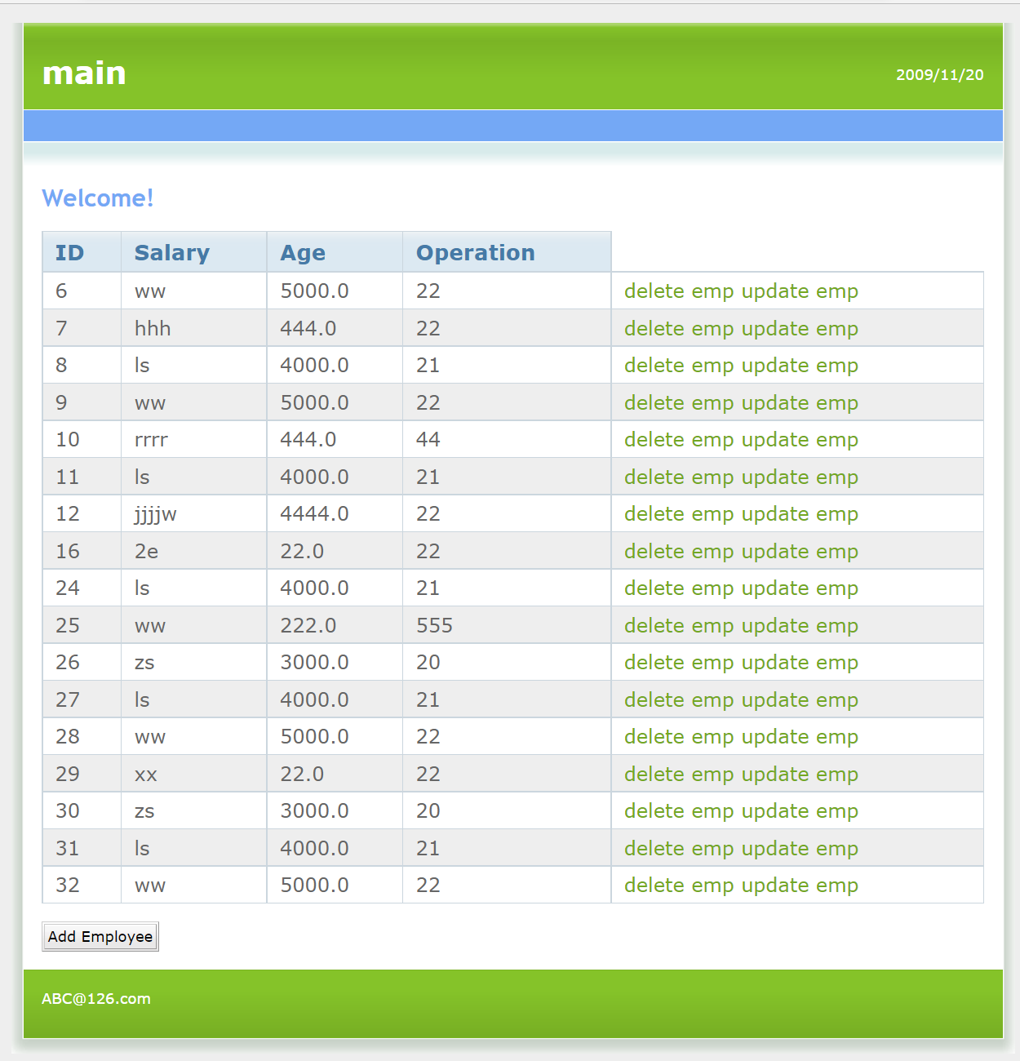

添加
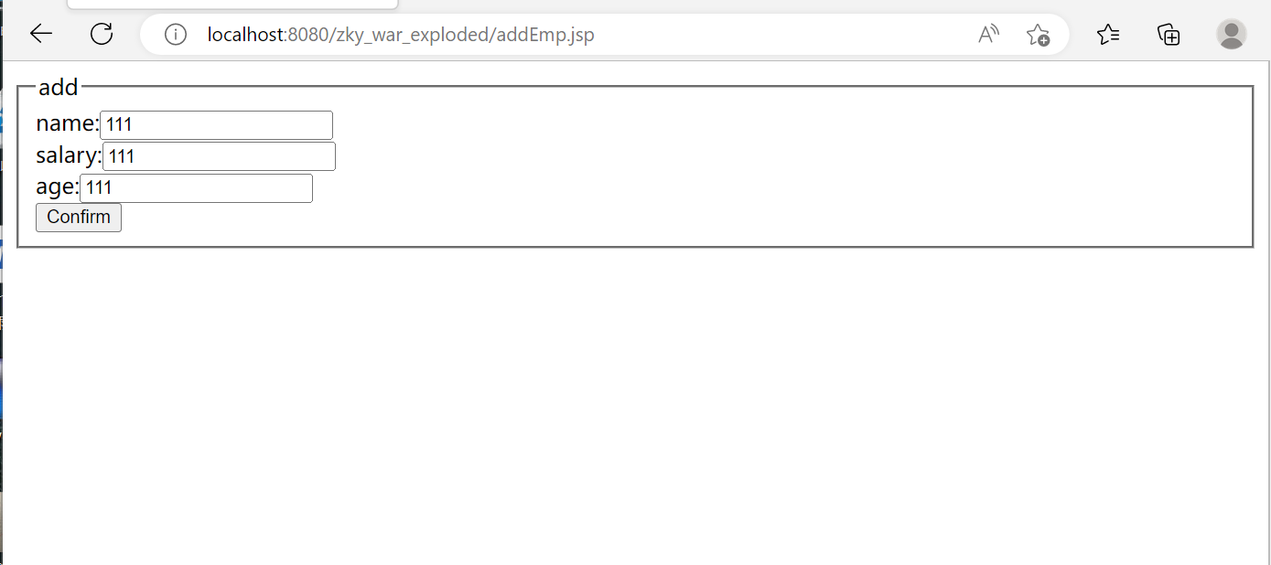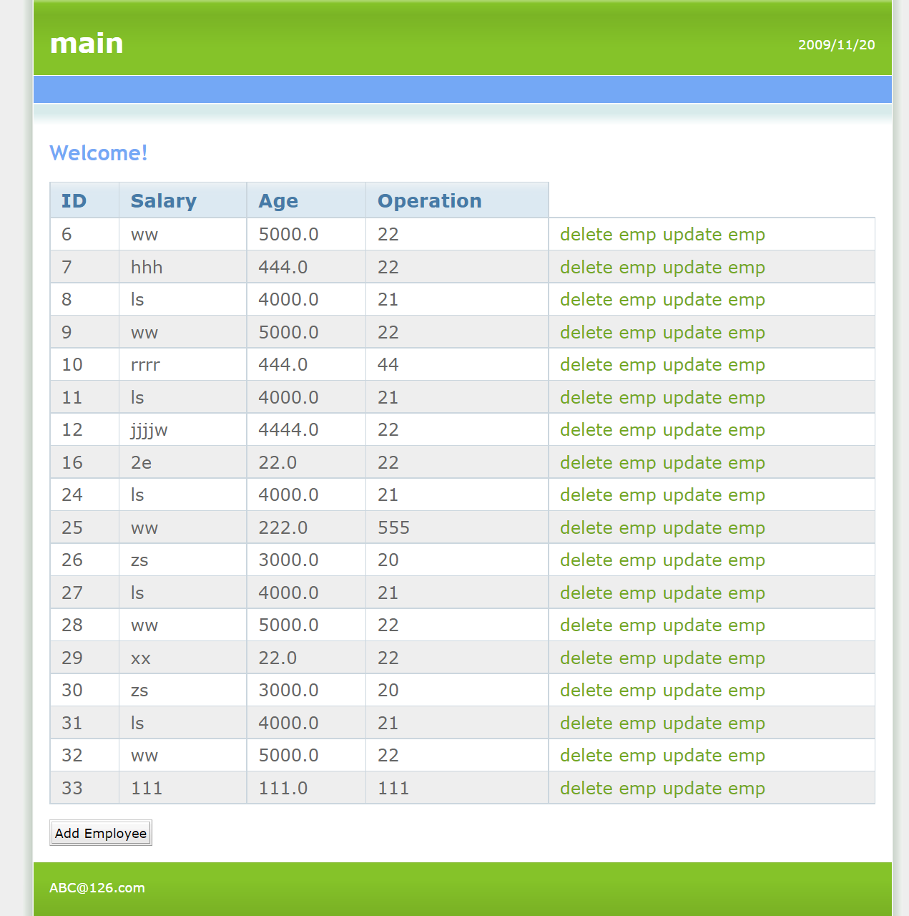

更新